**CAAP Quarterly Report**

Date of Report: 4/15/2025

Prepared for: *U.S. DOT Pipeline and Hazardous Materials Safety Administration*

Contract Number: 693JK32050008CAAP

Project Title: Effectiveness Assessment of Pipeline Cathodic Protection System Using Remote Sensing, Advanced Modeling, and Data Analytics

Prepared by: Xingsen Yang (PhD student), Jay Shah (Postdoc), Qixin Zhou (Co-PI), Hao Wang (PI)

Contact Information: Hao Wang, hwang.cee@rutgers.edu, 848-445-2874

For quarterly period ending: 03/31/2025

**Business and Activity Section**

# Contract Activity

The subaward to University of Akron has been issued.

# Status Update of Past Quarter Activities

One PhD student (Xingsen Yang) worked on this project with the postdoc (Jay Shah) at Rutgers University. Two undergraduate students (Ashley Chow and Cecilia Segretario) worked on this project at University of Akron.

The project team worked on the following tasks:

Task 2 Laboratory Tests of CP Performance under Various Factors

Task 3 Modelling and Simulation of CP Performance

Task 4 Remote Inspection of Soil Properties and Pipe Corrosion

# Cost Share Activity

Cost share is provided by Rutgers University and University of Akron during this quarterly period as budgeted in the proposal.

# Technical Approach

Task 1 Literature Review, Information Collection, and Refinement of Work Plan (completed)

Task 2 Laboratory Tests of CP Performance under Various Factors

Experimental study is started to evaluate the effectiveness of CP on the pipeline corrosion under different soil environments. The experimental setup set up to integrate applying cathodic protection (CP) while conducting electrochemical measurements, as shown in Figure 1.

Figure 1 Electrochemical monitoring for metal coupons under different soil environments with cathodic protection.

The soil used for the study was Quikrete all-purpose soil purchased from The Home Depot. The soil was put into a testing soil box and prepared by a proctor compactor to achieve a similar compacted level. The moisture content in soil was adjusted by a mixed solution to meet the designed values. The mixed solution was 8.933 g/L KCl, 1.170 g/L MgSO4∙7H2O, and 5.510 g/L NaHCO3. 10, 20, and 30 wt.% moisture content were studied this quarter.

The CP potential under study was 0, -850, and -1100 mV CSE, respectively. The metal for investigation was X70 steel. The mounted electrode was used for electrochemical measurement. The weight loss coupon of X70 was used for weight loss measurement. The corrosion rates were measured by Tafel testing and weight loss measurement, respectively. The location of the testing coupon was maintained at 30 cm below the surface of the soil.

The experimental procedures were as follows: 1) open circuit potential (OCP) for 55 mins to make sure the system to achieve the steady state, 2) linear polarization resistance (LPR) measurement for 5 mins to measure the initial polarization resistance, 3) repeating loop every 12 hrs for 14 times (equally 7 days) in a series of a) applying CP potential for 11 hrs, b) OCP for 55 mins, c) LPR for 5 mins, 4) the final OCP for 1 hr, and 5) Tafel testing for 1 hr. The moisture content, pH, and resistivity of the soil were monitored during the testing time.

The metal coupons under 10 wt.% moisture content with and without cathodic protection after 7 days of testing are shown in Figure 2. The samples without cathodic protection show more corrosion spots on the metal surface than those with the cathodic protection.

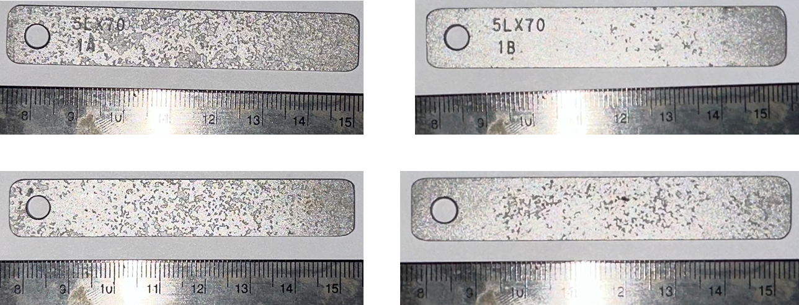

Figure 2 Weight loss coupons after 7 days of the testing: the left two samples were under 10 wt.% moisture content without cathodic protection; the right two samples were under 10 wt.% moisture content with CP of -850 mV CSE.

An experimental plan considering testing parameters, metal coupons, soil samples, and testing procedures was developed. The experimental setups will apply CP coupled with electrochemical measurements. The investigating parameters include CP levels, moisture content, soil pH, soil type, coupon location in the soil, and total experimental time with CP. The testing/monitoring parameters include soil resistance, moisture content, pH, true CP potential feedback, and corrosion rate. The corrosion rate can be measured by electrochemical measurement and weight loss measurement. The metal for investigation is X70. The metal will be fabricated into electrodes for electrochemical measurements.

The students are identifying and purchasing the required experimental materials and devices for the testing, including metal coupons, soil samples, soil sensors (moisture content and pH), proctor compactor, soil meters, chemicals, etc.

Task 3 Modelling and Simulation of CP Performance

**Experiment for Model Validation**

The simulation model of pipe corrosion in soil was validated using experimental setup in the literature. The geometric setup of the model was based on the experimental configuration described in Azoor et al. (2019), which used a custom-designed electrochemical test cell to evaluate corrosion behavior under controlled soil saturation conditions. As shown in Figure 3(a), the test cell consisted of a 3D-printed cylindrical body and cap to house the soil and ensure repeatable electrode positioning. A cross-sectional 2D schematic illustrates the compacted soil region and the placement of the three-electrode system, including a working electrode, counter electrode, and reference electrode. As shown in Figure 3(b), the cross-sectional schematic illustrates the compacted soil and electrode configuration. The test cell had a diameter of 55 mm and a total height of 76 mm, with the soil layer occupying the central region of 33 mm in height and 39 mm in diameter. Following this design, a 2-D finite element model was constructed with the same dimensions as the experimental setup shown in Figure 1(b). The geometry was defined to replicate the compacted soil region and the electrode placement within the cell, allowing direct comparison between simulation results and experimental observations.

Fig 3 The electrochemical cell design and schematic. (a) The cell design used in this study consists of a main body and cap and enables consistent placement of the electrodes. (b) Schematic illustrating the cross-sectional view of the compacted soil shows the electrode placement ATP (Azoor et al., 2019).

**Input Parameters**

Azoor et al. (2019) provided direct measurements of several key parameters relevant to corrosion in unsaturated soils. In this model, those experimentally obtained values and relationships are used directly as inputs to ensure consistency and realism. The study included three types of soil: sand, silt, and clay. Each of these soils exhibits distinct hydraulic and transport properties. These differences are reflected in the parameter values assigned in the model. These include the soil water retention curve (SWRC), oxygen diffusion coefficient, and the potentiodynamic polarization curves of different types of soil. Each parameter was defined as a function of the degree of saturation to capture the moisture-dependent behavior of unsaturated soils.

The soil water retention curves were derived by fitting the experimental data to the van Genuchten (vG) model. The vG equation is shown below. The fitted vG model parameters for each soil type were obtained directly from the experimental data provided by Azoor et al. (2019). A summary of the fitted parameter values for sand, silt, and clay is also provided in Table 1.

$$S_{e}=\frac{θ-θ_{r}}{θ_{s}-θ_{r}}={[1+{(αh)}^{n}]}^{-m}, m=1-1/n$$

Where, *Se* is the effective saturation, *θ* is the volumetric water content, *θs* and *θr* are the saturated and residual water contents, *h* is the soil suction (pressure head), and *α*, *n*, and *m* are fitting parameters.

Table 1 Fitted vG model parameters for sand, silt, and clay based on experimental data

|  |  |  |  |
| --- | --- | --- | --- |
|  | Sand | Silt | Clay |
| α (1/m) | 2.2713 | 0.5011 | 0.1215 |
| n | 11.455 | 1.415 | 1.3558 |

Since the soil specimens in the experiment were compacted and the height of the soil column was relatively small (33 mm), the water content was assumed to be uniform throughout the domain. Therefore, the SWRC was not expected to influence the corrosion process during the experiments. Moreover, the focus of the study was to compare corrosion rates under different fixed saturation levels. As a result, the SWRC was not directly used as an input in this model. Nevertheless, obtaining the SWRC remains important for future modeling of CP systems in the field, where moisture redistribution and unsaturated flow will significantly influence corrosion behavior along different soil depth. The consistency between the SWRC and other measured parameters also ensures a solid foundation for the extension of this model.

The oxygen diffusion coefficient plays a key role in determining the availability of oxygen at the metal surface and is therefore directly linked to corrosion activity. In the referenced study, Azoor et al. (2019) reported the variation of diffusion coefficient as a function of the degree of saturation for sand, silt, and clay. As shown in Figure 4, the diffusion coefficient exhibits distinct trends for the three soil types. For all soils, the coefficient remains relatively stable at lower degrees of saturation, then decreases significantly as saturation increases. This drop is most pronounced in clay, which maintains a higher diffusion capacity up to near full saturation, while sand shows a steeper decline at lower saturation levels due to its larger pores and faster air phase disconnection. These differences reflect the contrasting pore structures and air-filled connectivity of the materials. In this model, the diffusion coefficient was incorporated as a predefined analytical function of saturation, using the smoothed curves fitted from the experimental data.

Figure 4 Variation of oxygen diffusion coefficient with degree of saturation for sand, silt, and clay based on experimental data reported by Azoor et al. (2019).

Electrical conductivity is an important factor in corrosion modeling. However, the referenced study did not provide a quantitative relationship between conductivity and moisture. Thus, the empirical relationship between moisture content and electrical conductivity from other existing literature was used. Given the small size of the experimental cell, the role of conductivity was likely minimal in this context. This was verified by simulation results.

In addition to transport-related parameters, the polarization behavior of the metal surface was also characterized in the experimental study. Azoor et al. (2019) provided polarization curves for each of three soil types. Based on these curves, Tafel parameters were extracted using electrochemical analysis methods. The derived Tafel slopes and corrosion potentials reflect the specific electrochemical environment associated with each soil type. These values were used in the model to define the anodic and cathodic kinetics at the metal–soil interface. A summary of the fitted Tafel parameters is presented in Table 2.

Table 2 Electrochemical parameters derived from polarization tests for sand, silt, and clay

|  |  |  |  |
| --- | --- | --- | --- |
|  | Sand | Silt | Clay |
| Tafel slope iron oxidation (V) | 0.132 | 0.045 | 0.071 |
| Tafel slope oxygen reduction (V) | -0.121 | -0.118 | -0.115 |
| Iron oxidation equilibrium potential  (V) | -0.75 | -0.76 | -0.76 |
| Oxygen reduction equilibrium potential (V) | 0.188 | 0.195 | 0.179 |
| Iron oxidation exchange current density (A/m2) | 7.12×10-5 | 7.06×10-5 | 7.21×10-5 |
| Oxygen reduction exchange current density (A/m2) | 7.83×10-7 | 7.71×10-7 | 7.76×10-7 |

As previously discussed, electrical conductivity was not a controlling variable in this special setup, given the small cell size and uniform corrosion pattern. Therefore, among the factors discussed so far, oxygen diffusion is the only one that has both moisture-dependent variation and influence on corrosion behavior. However, its effect is strictly monotonic with respect to saturation and therefore cannot explain the experimentally observed non-linear trend. However, experimental results demonstrated the existence of an optimum saturation degree where corrosion was maximized. This suggests the presence of another mechanism modulated by moisture. Experimental results, nonetheless, demonstrated the existence of an optimum saturation degree where corrosion was maximized. This observation implies that one or more additional mechanisms, modulated by moisture, may be contributing to the non-linear behavior.

Prior studies have proposed that the active anodic area may also be governed by the degree of saturation (Melchers, 2003; Sogo et al., 2018). A relationship proposed in another experimental study was adopted in this model (Azoor et al., 2018). Specifically, this study performed image analysis of the percentage of corroded electrode surface, which is defined as the active area, under varying saturation conditions have demonstrated a near one-to-one correlation between the active area ratio and the degree of saturation. Therefore, the model introduces the concept of active area as an additional factor, implemented as a multiplicative term for corrosion current in the anode. This factor is assumed to vary linearly with *Sr*, providing the second moisture-dependent mechanism that counterbalances the monotonic influence of oxygen diffusion.

**Experiment vs. Model Results**

The simulation results of corrosion current density are presented and compared with the experimental data reported by Azoor et al. (2019). Using the experimentally derived input parameters described previously, including soil-specific oxygen diffusion coefficients, Tafel parameters, and the saturation-dependent active area ratio, the model predicts the steady-state corrosion current density (*iFe*) for a range of saturation conditions. These outputs are used to evaluate the model’s ability to replicate the observed peak corrosion behavior across different soil types.

Figures 6, 7 and 8 display both the simulated and experimental corrosion current density results as functions of degree of saturation for the three soil types. Across all soil types, the corrosion rate exhibits a clear non-monotonic trend: it initially increases with saturation, reaches a maximum at an intermediate *Sr*, and then decreases as saturation continues to rise. This trend reflects the balance between enhanced electrolyte contact and limited oxygen diffusion. Additionally, the comparison reveals that silt exhibits the highest corrosion rate among the three soils, followed by clay and then sand. The corrosion current in silt also shows a more pronounced variation across the range of saturation, suggesting greater sensitivity to moisture conditions in this soil type.

For silt and clay, the model closely reproduces the experimental trends, accurately capturing both the location of the corrosion peak and the overall shape of the response curve. In silt, the optimum degree of saturation is found at approximately 0.7, while in clay it occurs near 0.8. Both values align well with the experimental observations and reflect the moisture levels at which the competing effects of oxygen availability and electrolyte connectivity reach a critical balance. Although there are slight differences in the absolute values of corrosion current density between the simulations and measurements, these discrepancies remain within an acceptable range. A likely explanation of this deviation is the process of extracting Tafel parameters from the polarization curves, which inherently introduces some uncertainty due to the idealized fitting and assumptions involved in that analysis. These outcomes indicate that oxygen diffusion and saturation-dependent active area are the primary factors controlling corrosion behavior in fine-grained soils.

For sand, the model shows more notable deviation in corrosion current density values that are much smaller than those observed in silt and clay. Although the non-monotonic trend is preserved, and the magnitude of the corrosion current density remains close to measured values, the predicted peak occurs at a higher *Sr* than observed. This discrepancy may be related to the fact that, due to gravitational effects in the experimental setup, the assumption of a perfectly uniform saturation distribution is not entirely valid, especially at higher saturation levels. In higher saturation cases, water tends to accumulate toward the bottom of the soil column, which corresponds to the region near the working electrode. This creates a local increase in saturation compared to the overall average. Such an effect is more pronounced in sand due to its coarser texture and more rapid drainage behavior. This likely contributes to the shift observed in the predicted optimum saturation point.

Figure 6. Comparison between simulated and experimental corrosion current densities for sand under varying degrees of saturation.

Figure 7. Comparison between simulated and experimental corrosion current densities for silt under varying degrees of saturation.

Figure 8. Comparison between simulated and experimental corrosion current densities for clay under varying degrees of saturation.

Task 4 Remote Inspection of Soil Properties and Pipe Corrosion

A triple-frequency GPR system (supplied by U.S. Radar Inc.) was newly purchased and employed for this study. The antenna provides scans at multiple frequencies and supports wireless transmission to a tablet. The acquired data were post-processed using Radan software by GSSI. Figure 9 shows the GPR setup used in this study.

Figure 9. GPR setup on soil box

Once the box was filled with sand to the desired depth, it was left undisturbed to allow moisture to redistribute naturally. At the beginning of the experimental observations, the moisture content recorded by the top, middle, and bottom sensors was 21%, 12.1%, and 27.1%, respectively. For the pipeline scan, the antenna was traversed across the pipeline, whereas for the plate, the antenna was kept static directly above its location. Due to the small dimensions of the sandbox, all scans were conducted in time-scan mode instead of the more commonly used distance mode, which typically requires a GPR cart.

Figure 10 shows the scan corresponding to the plate reflection. Three main peaks were identified in the A-scan. Peak A is interpreted as the direct wave between the transmitter and receiver. This is followed by Peak B at approximately 7 ns, which is likely due to the moisture contrast between the top and middle soil layers, with moisture contents of 21% and 12.1%, respectively. A strong reflection observed at around 12 ns corresponds to Peak C, which is attributed to the buried plate.

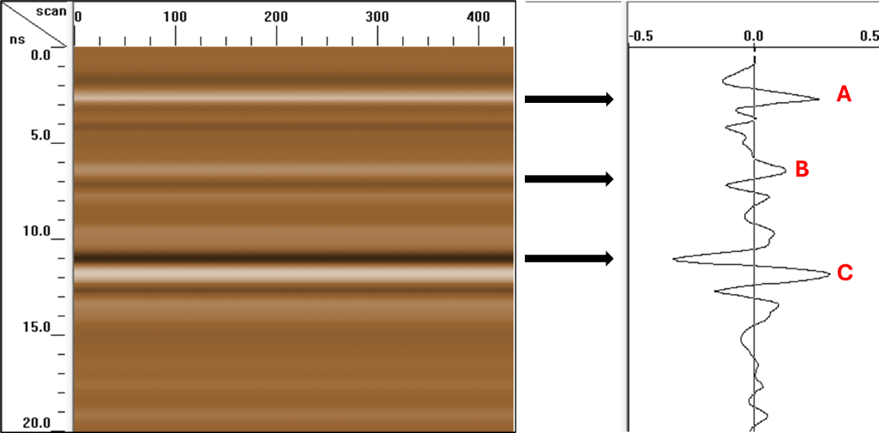

Figure 10. GPR scan on the plate

Figure 11 shows the GPR scan for the 2-in. pipe. The pipe reflection is evident from the hyperbolic signature, highlighted within the dashed red curves. The accompanying A-scan corresponds to a specific location at the apex of the hyperbola, indicated by the dashed vertical line. When compared to the plate scan, both similarities and differences can be observed. As in the plate scan, Peaks A and B are present, corresponding to the direct wave and the first moisture boundary, respectively, with the latter associated with a moisture content of approximately 12%. However, the reflection pattern from the metal pipe is relatively distinct in shape, due to the geometry and orientation of the cylindrical reflector.

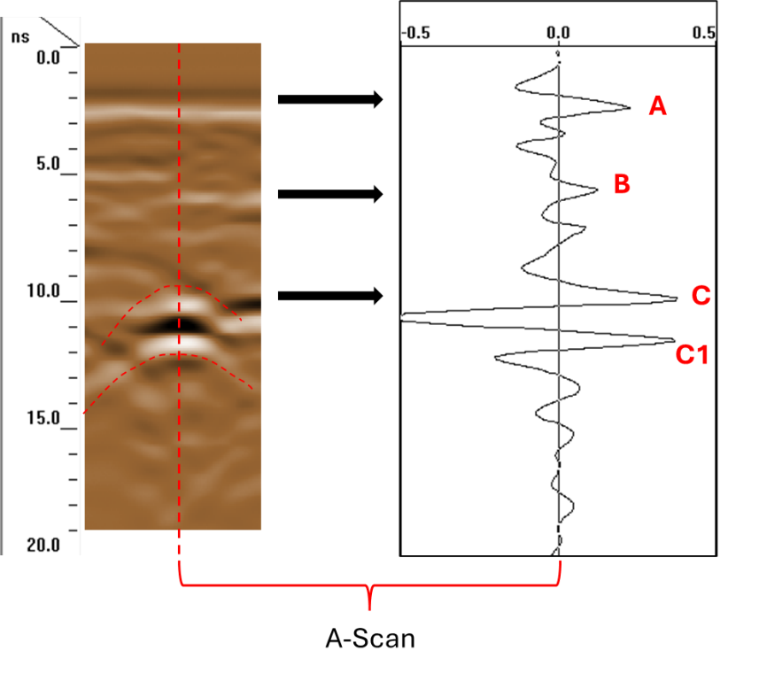

Figure 11. GPR scan on 2 in. pipe

When compared to the shape of the antenna pulse shown in Figure 12, it is desirable for the metal reflection to exhibit a similar signal shape. In the plate scan—taken with the GPR antenna in a static position—the reflection peak (C) closely resembles the original antenna pulse shape. In contrast, the pipe reflection consists of two distinct peaks (C and C1). This could potentially be attributed to the curvature of the pipe, which introduces additional complexity, not present in the flat plate reflection. Another possible explanation is the interference or merging of the pipe reflection with a reflected signal from a moisture boundary, where the moisture content was measured to be 28% by the sensor.

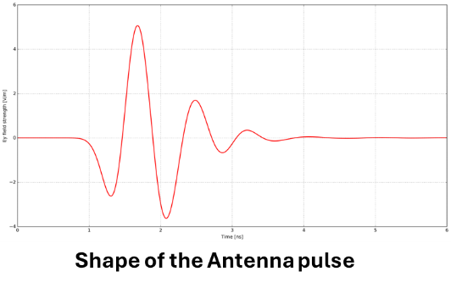

Figure 12. Pulse shape sent by GPR

Figure 13 shows the variation in A-scans (obtained at the peak of the hyperbola) across different days, corresponding to varying moisture conditions. For clarity, results from the days with the highest, intermediate, and lowest recorded moisture at the bottom of the sandbox are compared. The moisture configurations (top/middle/bottom in %) for the selected days are as follows: 21/12.1/28 for March 10; 19.4/11.5/24.3 for March 26; and 18.5/10.9/22.2 for March 31. It is evident that as the moisture around the pipeline decreases, a leftward shift is observed in the peak at approximately 6 ns, as well as in the peaks between 10 and 14 ns. This shift can be directly interpreted as increase in wave velocity due to decrease in the dielectric constant.

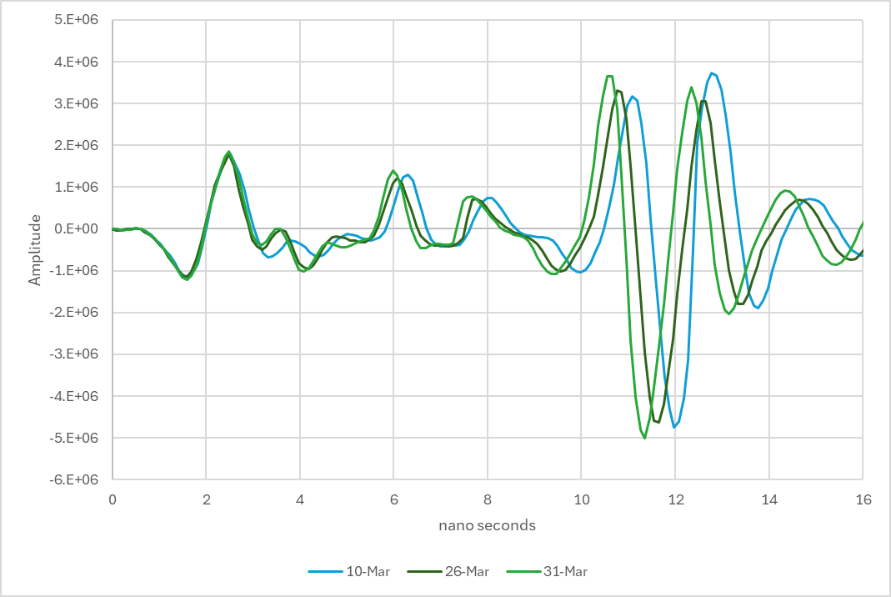

Figure 13. A- scans on 2 in. pipe in two days having different moisture distributions

The consistency of the above interpretation was further validated when similar moisture profiles were recorded on different measurement days. On such days, the A-scans were found to be comparable, as shown in Figure 14. The moisture profiles (top/middle/bottom in %) were 19/10.6/22.7 on March 14, and 19.3/11.3/23 on March 27. These observations reinforce the reliability and repeatability of the reported methodology.

w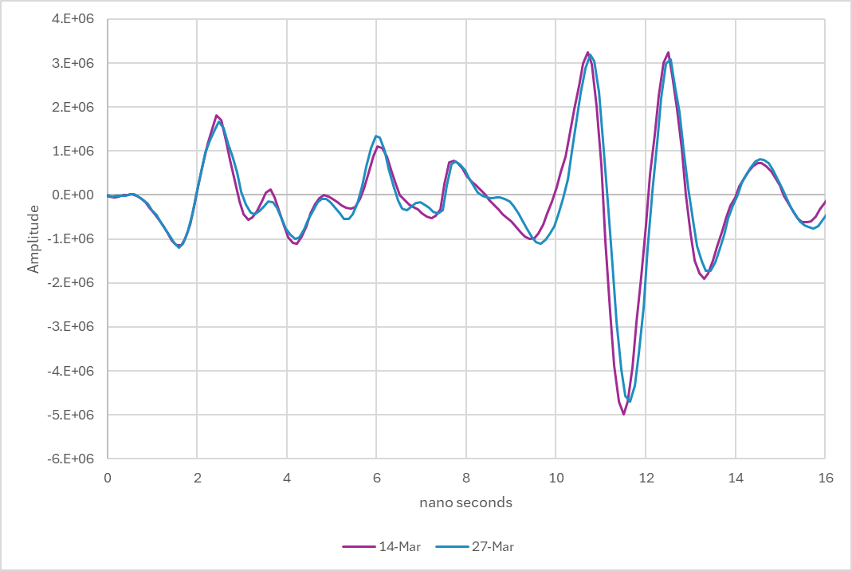

Figure 14. Similarity in A-scans on 2 in. pipe in two days having similar moisture distributions

Similar to the observations in the previous section, a leftward shift in the observed peaks is evident in Figure 15 with decreasing moisture content. The moisture profiles (top/middle/bottom in %) were 20.1/12.1/27.1 on March 18 and 18.5/10.9/22.2 on March 31. This shift is attributed to an increase in pulse velocity resulting from a decrease in the dielectric constant. Furthermore, the GPR scans remain consistent across different inspection days with similar moisture conditions, as shown in Figure 16. This observation further supports the reliability of the reported methodology.

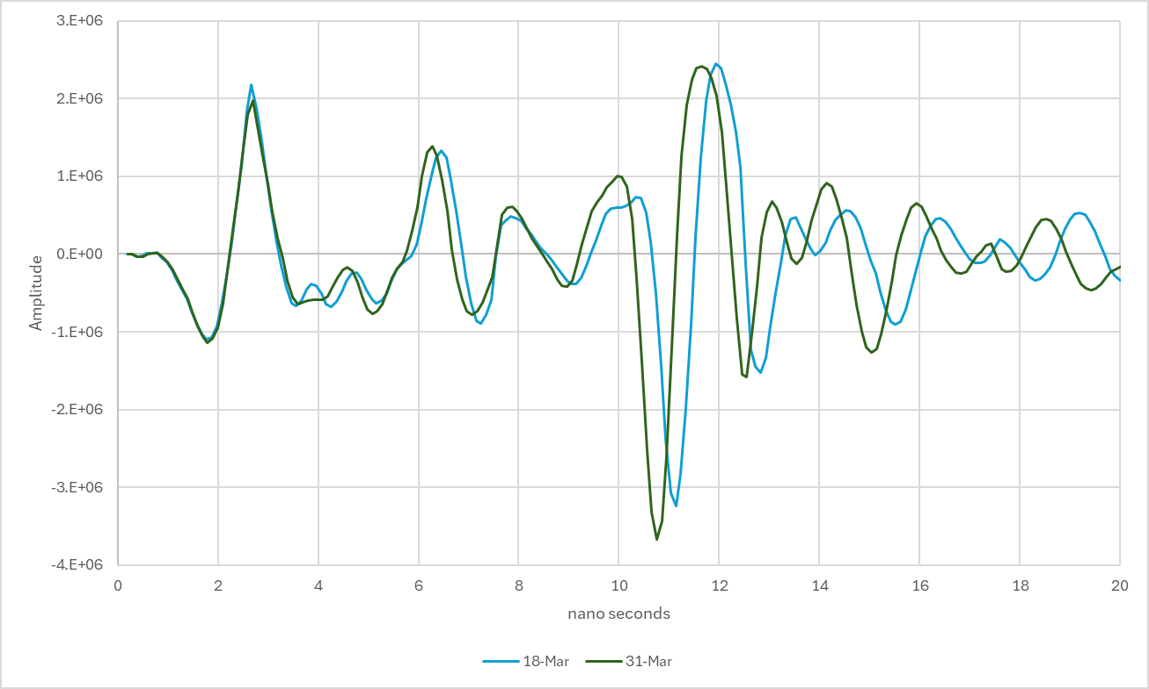

Figure 15. Comparison of A-scans on the plate in two days having different moisture distributions

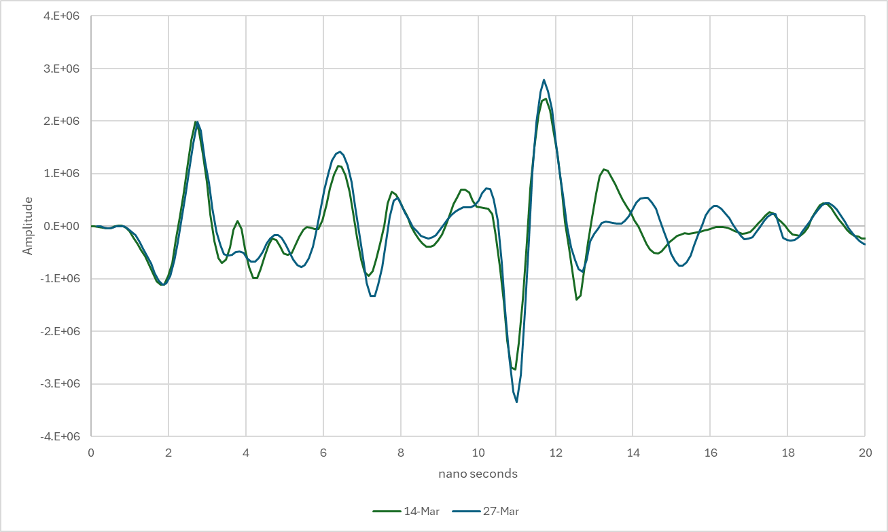

Figure 16. Similarity in A-scans on the plate on in two days having similar moisture distributions